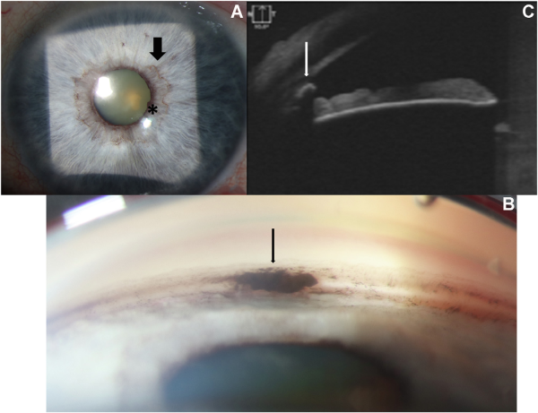

A 78-year-old man presented with blurry vision in the left eye and was found to have a hyphema (not pictured). Upon resolution of thehyphema, slit-lamp photography (A) demonstrated superficial, prominent vessels of the minor arterial circle at the iris collarette(wide arrow) and small flocculi at the pupillary margin (A, asterisk). Gonioscopy showed a wrinkled pigmented lesion in the inferior angle(B, narrow arrow). Anterior-segment OCT showed a hyperreflective lesion (white arrow) with acoustic shadowing in the inferiorangle, confirming the cystic nature of the lesion (C). Based on the provided images and clinical description please make an ophthalmic diagnosis for this patient. And output the diagnostic conclusions only.

**Iris cyst**